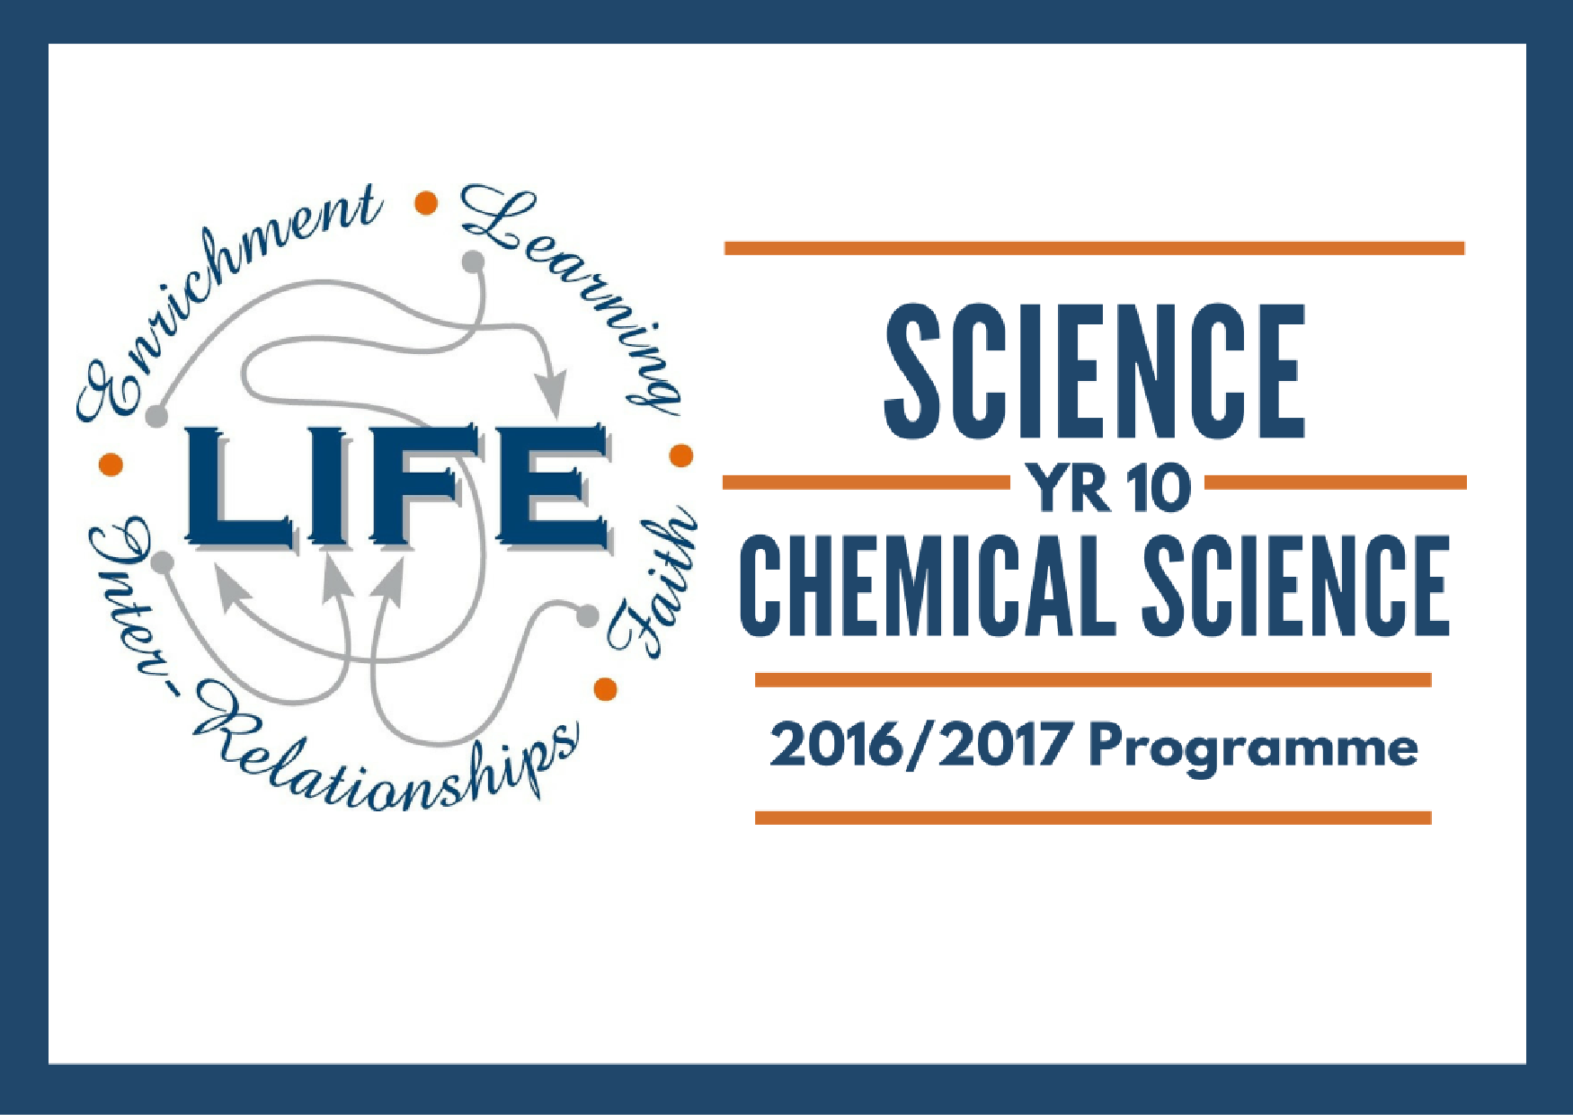

Contents  Contents  Resources  Australian Curriculum Links  Science Understanding  Science as a Human Endeavour  Science Inquiry Skills  Programme  Assessment Structure | Resources  - JacPlus Science Quest 10  - Education Perfect  - Yr 10 Chemical Science Google Site: https://sites.google.com/holycross.wa.edu.au/yr10chemicalscience/home

Australian Curriculum Links

Science Understanding

Chemical Sciences
The atomic structure and properties of elements are used to organise them in the Periodic Table (ACSSU186) | - recognising that elements in the same group of the periodic table have similar properties  - describing the structure of atoms in terms of electron shells  - explaining how the electronic structure of an atom determines its position in the periodic table and its properties  - investigating the chemical activity of metals
Different types of chemical reactions are used to produce a range of products and can occur at different rates (ACSSU187) | - investigating how chemistry can be used to produce a range of useful substances such as fuels, metals and pharmaceuticals  - predicting the products of different types of simple chemical reactions  - using word or symbol equations to represent chemical reactions  - investigating the effect of a range of factors, such as temperature and catalysts, on the rate of chemical reactions

Science as a Human Endeavour

Nature and development of science
Scientific understanding, including models and theories, is contestable and is refined over time through a process of review by the scientific community (ACSHE191) | - investigating the development of the periodic table and how this was dependent on experimental evidence at the time  - considering the role of science in identifying and explaining the causes of climate change
Use and influence of science
People use scientific knowledge to evaluate whether they accept claims, explanations or predictions, and advances in science can affect people’s lives, including generating new career opportunities (ACSHE194) | - predicting future applications of aspects of nanotechnology on people’s lives  - using knowledge of science to test claims made in advertising  - considering how the computing requirements in many areas of modern science depend on people working in the area of information technology  - considering the scientific knowledge used in discussions relating to climate change  - evaluating claims relating to environmental footprints  - recognising that scientific developments in areas such as sustainable transport and low-emissions electrical generation require people working in a range of fields of science, engineering and technology
Values and needs of contemporary society can influence the focus of scientific research (ACSHE230) | - investigating technologies associated with the reduction of carbon pollution, such as carbon capture  - investigating the use and control of CFCs based on scientific studies of atmospheric ozone  - recognising that financial backing from governments or commercial organisations is required for scientific developments and that this can determine what research is carried out

Science Inquiry Skills

Questioning and predicting
Formulate questions or hypotheses that can be investigated scientifically (ACSIS198) | - Elaborations  - developing hypotheses based on well-developed models and theories  - using internet research to identify problems that can be investigated  - formulating questions that can be investigated within the scope of the classroom or field with available resources  - developing ideas from students own or others' investigations and experiences to investigate further  - evaluating information from secondary sources as part of the research process
Planning and conducting
Plan, select and use appropriate investigation types, including field work and laboratory experimentation, to collect reliable data; assess risk and address ethical issues associated with these methods (ACSIS199) | - combining research using primary and secondary sources with a student's own experimental investigation  - using modelling and simulations, including using digital technology, to investigate situations and events  - deciding how much data are needed to produce reliable measurements  - considering possible confounding variables or effects and ensuring these are controlled  - identifying the potential hazards of chemicals or biological materials used in experimental investigations  - identifying safety risks and impacts on animal welfare and ensuring these are effectively managed within the investigation
Select and use appropriate equipment, including digital technologies, to collect and record data systematically and accurately (ACSIS200) | - selecting and using probes and data loggers to record information  - applying specific skills for the use of scientific instruments  - identifying where human error can influence the reliability of data
Processing and analysing data and information
Analyse patterns and trends in data, including describing relationships between variables and identifying inconsistencies (ACSIS203) | - using spreadsheets to present data in tables and graphical forms and to carry out mathematical analyses on data  - describing sample properties (such as mean, median, range, large gaps visible on a graph) to predict characteristics of the larger population, acknowledging uncertainties and the effects of outliers  - exploring relationships between variables using spreadsheets, databases, tables, charts, graphs and statistics
Use knowledge of scientific concepts to draw conclusions that are consistent with evidence (ACSIS204) | - using primary or secondary scientific evidence to support or refute a conclusion  - constructing a scientific argument showing how their evidence supports their claim
Evaluating
Evaluate conclusions, including identifying sources of uncertainty and possible alternative explanations, and describe specific ways to improve the quality of the data (ACSIS205) | - evaluating the strength of a conclusion that can be inferred from a particular data set  - distinguishing between random and systematic errors and how these can affect investigation results  - identifying alternative explanations that are also consistent with the evidence
Critically analyse the validity of information in primary and secondary sources, and evaluate the approaches used to solve problems (ACSIS206) | - researching the methods used by scientists in studies reported in the media  - judging the validity of science-related media reports and how these reports might be interpreted by the public  - describing how scientific arguments, as well as ethical, economic and social arguments, are used to make decisions regarding personal and community issues
Communicating
Communicate scientific ideas and information for a particular purpose, including constructing evidence-based arguments and using appropriate scientific language, conventions and representations (ACSIS208) | - using the internet to facilitate collaboration in joint projects and discussions  - constructing evidence based arguments and engaging in debate about scientific ideas  - presenting results and ideas using formal experimental reports, oral presentations, slide shows, poster presentations and contributing to group discussions  - using a range of representations, including mathematical and symbolic forms, to communicate science ideas

Programme
Week | Topic | Content | Activities and Assessment Tasks | Resources
1 | The Periodic Table | - Distinguish between groups and periods of the periodic table  - Identify, describe and compare the different areas of the periodic table, metals, non-metals and metalloids.  - Identify, provide examples (i.e. elements), and describe properties of common groups on the periodic table including alkali metals, alkali earth metals, halogens and noble gases.  - Name the key contributor and their contributions to the periodic table and how this came about. | Diagnostic Quizlet | JacPlus CH 4.1
2 | Atomic Structure | - Use the periodic table and atomic numbers to calculate the number of protons in an element  - Use the mass number and atomic number to calculate the number of neutrons in a given isotope  - Calculate the number of electrons in a given element  - Write electronic configurations and draw electron shell diagrams for the first 20 elements | Making atoms activity  Flame Test | JacPlus CH 4.1 and 4.2
3 | Ionic Compounds | - Define and explain the ionic bonding  - State common properties of ionic compounds  - Calculate the charge of elements based on their position on the periodic table  - Provide examples of ionic compounds  - Write formulae of ionic compounds  - Name ionic compounds  - Calculate the number of electrons in different ions  - Write electronic configurations and draw electron shell diagrams for ions of the first 20 elements |  | JacPlus CH 4.3
4 | Ionic Compounds
5 | Chemical Equations | - Write worded chemical equations  - Balance chemical equations
6 |  |  |  | JacPlus CH 5.1
7 | Metal Displacement Reactions | - Write and balance equations for metal displacement reactions | Reactivity of Metals Practical Assessment
8 | Precipitation Reactions | - Identify, predict, write and balance equations for precipitation reactions | Common reaction demonstrations  Precipitation reactions practical | JacPlus CH 5.2
9 | Rates of Reactions | - Describe the function of catalysts  - Explain the effect of amount, surface area and temperature on chemical reactions | Rates of reactions demonstration | JacPlus CH 5.7
10 | Revision and Test |  | Topic Test (50%)

Assessment Structure
Topic | Weighting | Assessment Type | Title and Details | Approximate Date
Chemical Sciences | 10% | Practical | Reactivity of Metals Practical | Week 7
 | 10% | Test | Chemical Sciences Topic Test | Week 10

